**4.1 Setting up an acquisition**

1. Start the laser at 50MHZ. Adjust the intensity to 1µW using the Thorlabs optical power meter using the ferrule adapter (see also the building protocol).
2. Take a mouse and connect a patch cord to the implanted optical cannula in similar fashion as for optogenetics of fiber photometry.
3. Place the mouse in the behavioral set-up and start up the desktop.
4. 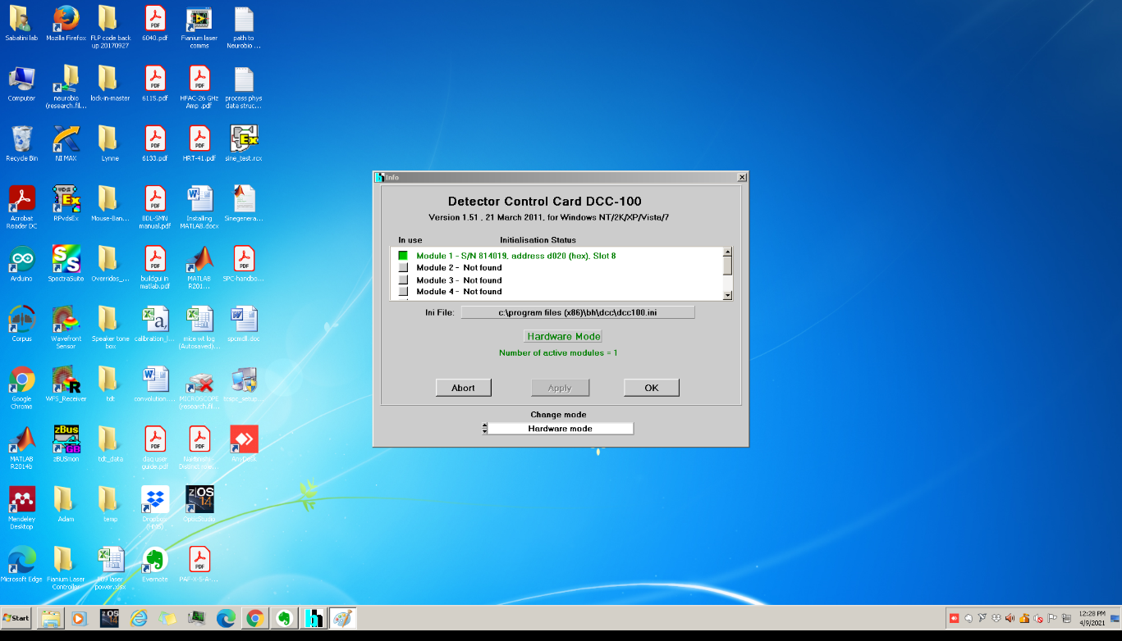Open the DCC-100 software and check whether your model is included
5. Press OK and set the gain settings on your device before clicking enable control. Please note that the beam shutter in front of the hybrid PMT is closed and no light should be entering the hybrid PMT yet. During acquisition, be sure to check the Overload (OVLD) lamp. If too much light enters the hybrid PMT then this can trigger shutdown of the PMT to prevent damage, however, the PMT can still be damaged regardless of this safety feature so always be careful.

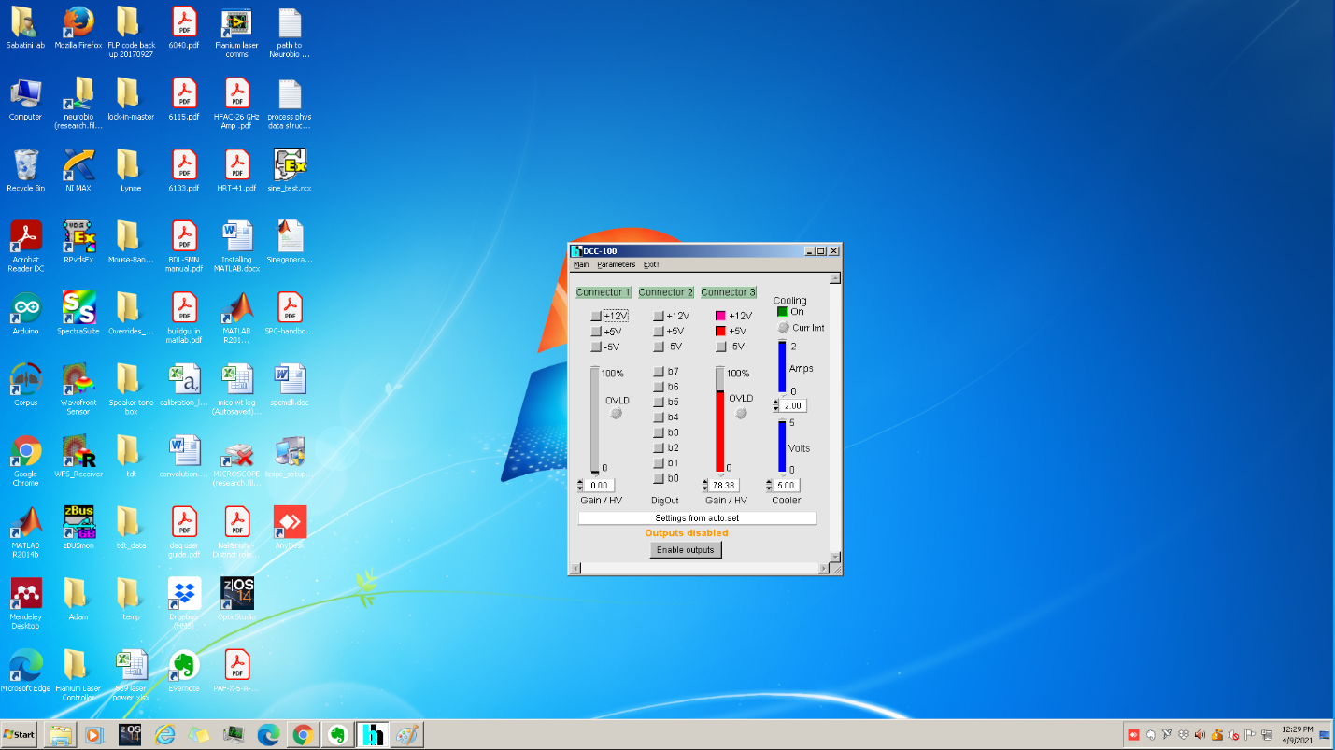

1. Open Matlab 2012. After installation, the acquisition software should start by itself.

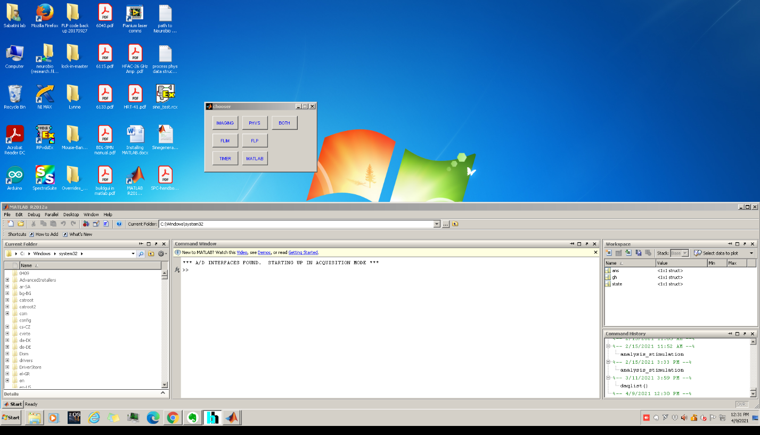

1. Press Phys in order to use both the NiDAQ cards for acquisition of behavioral variables, send out pulses and the possibility to detect photometry data (if not, create 2 virtual channels in NI-MAX in order for the software to run properly, NI PCI-6115 and PCI-6713). Named Phys and aux for the NI PCI-6115 and PCI-6713 input and output DAQ cards respectively.

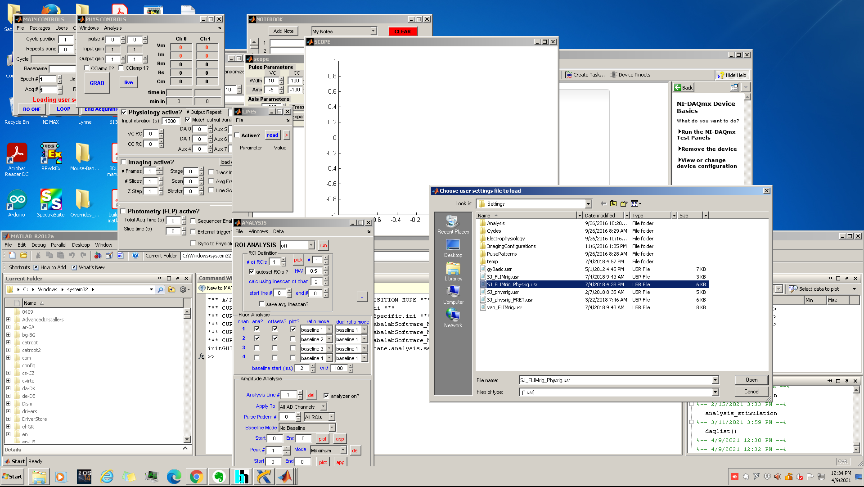

1. Select SJ_FLIMrig_Physrig package.

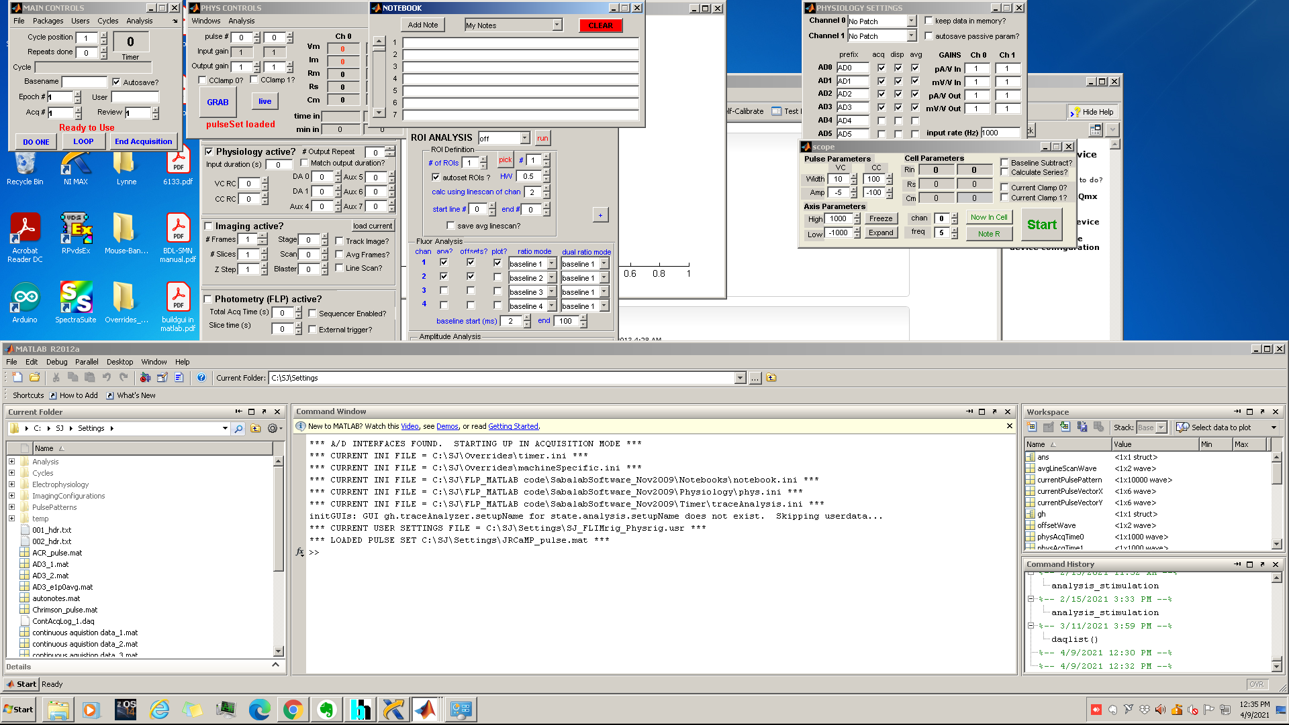

1. In the Main control window (left top) click packages->zFLP

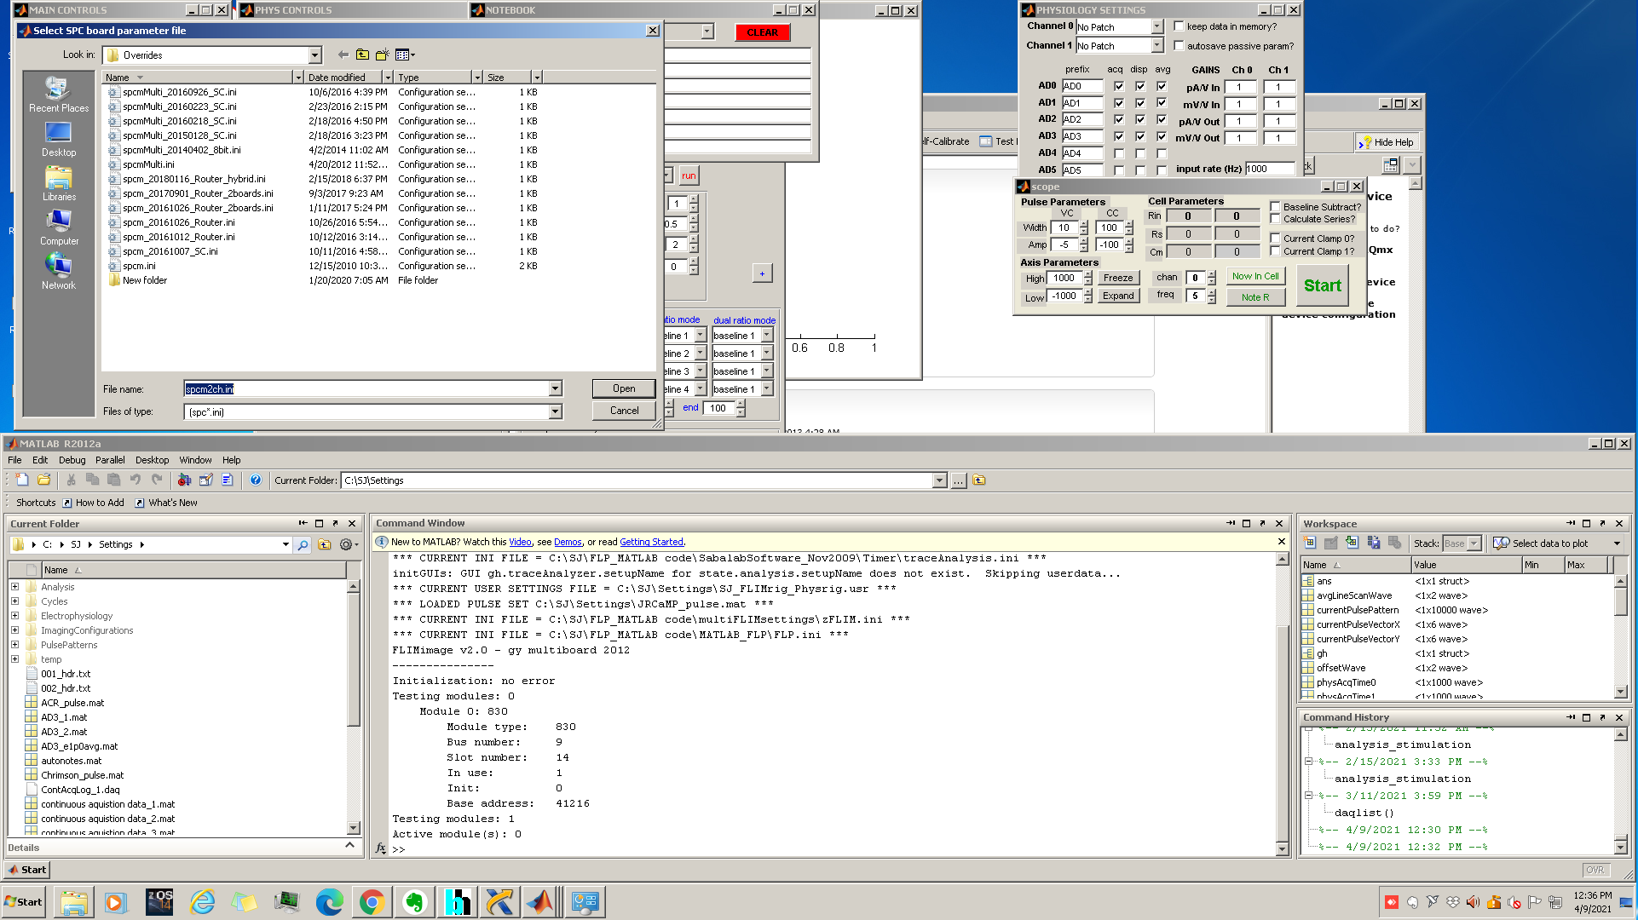

1. 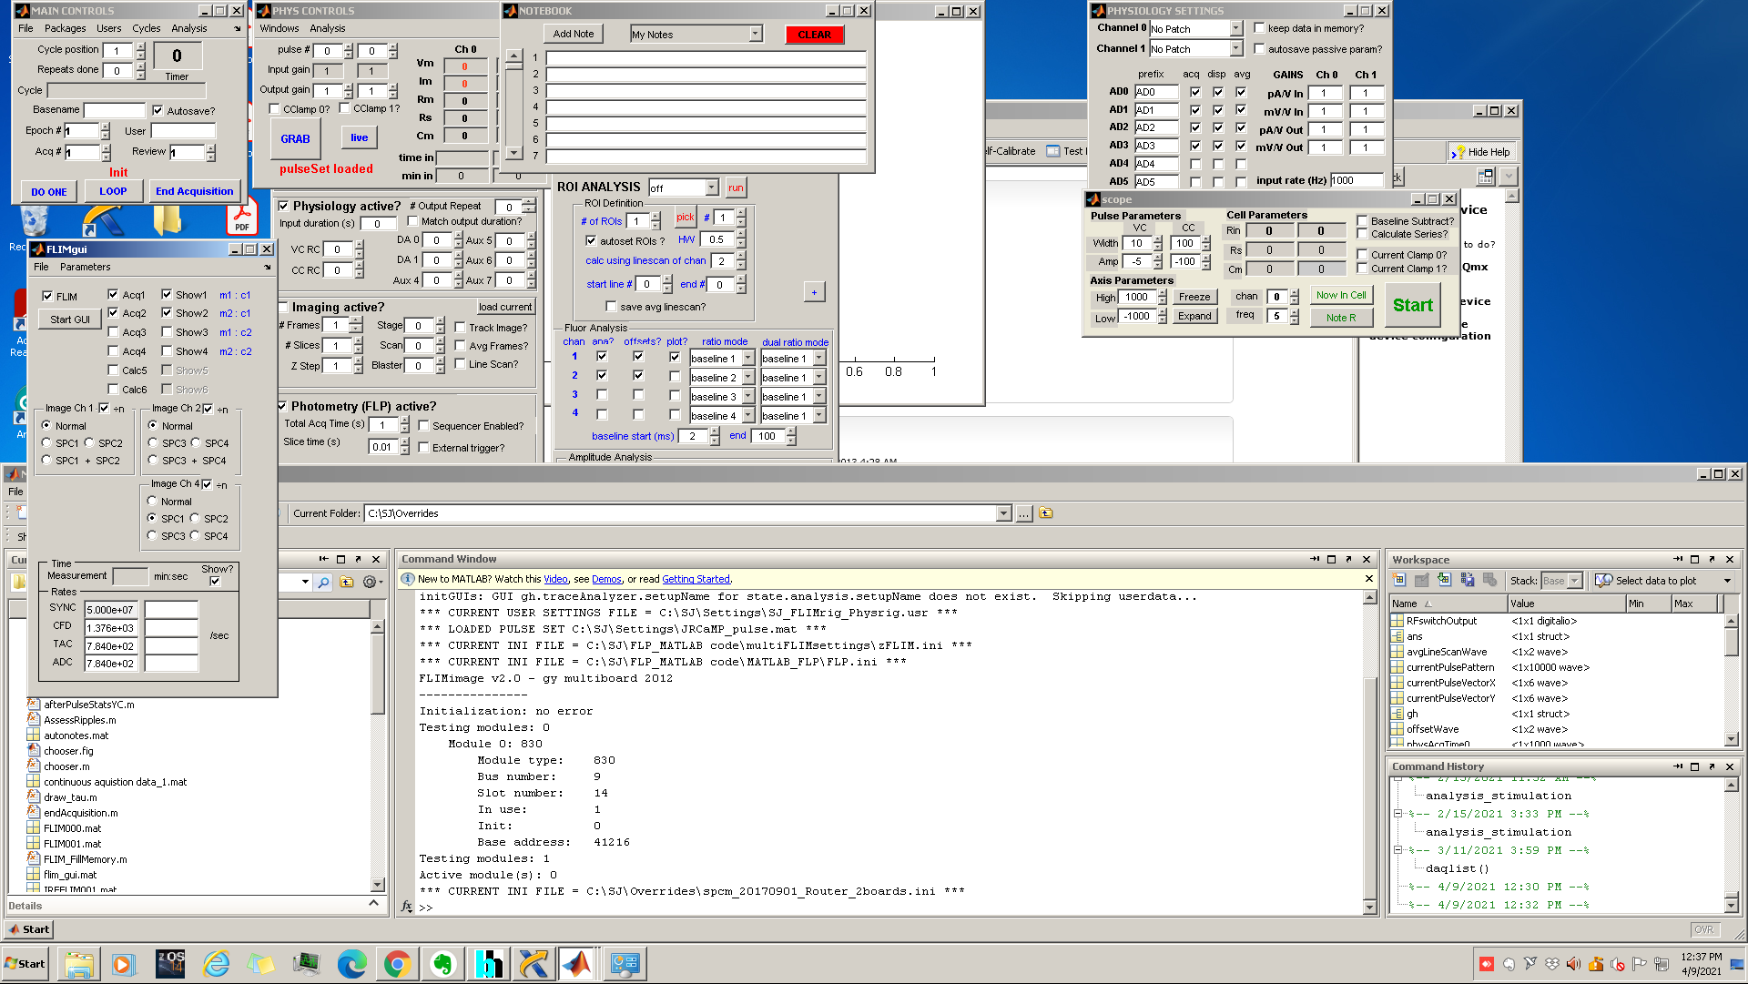Select: SPCM_20170901_Router-2boards.ini
2. Uncheck Acq2 and click start GUI in the FLIMgui window. Check the sync rate in the FLIMgui window to check if the reference pulse of the laser is being detected. In addition, observe the photon counts, which are displayed next to ADC label.

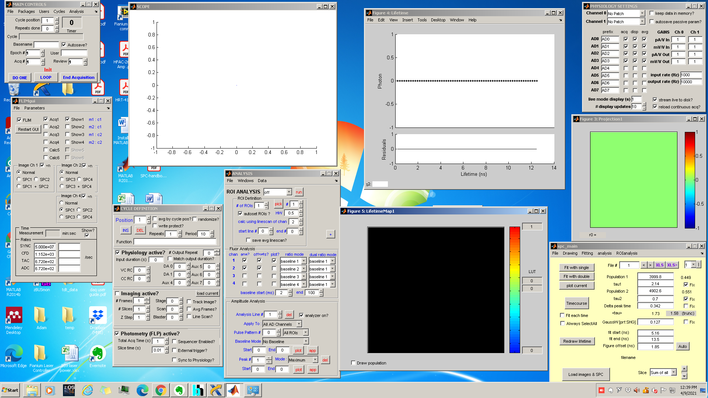

1. Order your windows and select the preferred options: In cycle definition, set input duration to infinite and set DA0 DA1 and other output ports to one if an output voltage pulse is required. Please note that the pulse generated from these output ports can be adjusted in the pulse settings window.
2. Change the total Acq Time (s) and slice time. Note that the slice time determines the temporal resolution of FLiP. When defining the slice time a few aspects have to be considered.
   1. The photon counts needed to properly estimate the lifetime of the fluorophore (we recommend between 2*105 and 2*105 photon counts for accurate estimation)
   2. The time it takes for the photon counting board to send data to the computer.
   3. The maximum photons a board can count reliably (in our case 1*106 sec-1).
   4. The distribution of photons coming back per laser pulse. Since this technique relies on single photon counting to estimate lifetime, the majority of laser pulses should have either no excitation event or single excitation events detected in the hybrid PMT.
3. In physiology settings change the amount of input channels in the Phys card you want to use. 1 channel should always be selected. By going to the analysis window, clicking windows and display data, you can visualize the data in real time. Set the time window of this visualization and which data is displayed in the physiology settings at the checkmark dip and the live mode display.
4. In SPC_main set the tau values of your fluorophore. Set the fit start and fit finish value. If this is the first acquisition, change the fit start and fit finish value and optimize them by measuring the lifetime histogram after acquisition. For now, continue with the default settings.
5. After changing these settings. Slowly open the manual shutter of the PMT, while looking at the photon counts per second (ADC) in the FLIMgui window. Also make sure to keep observing the DCC-100 app, to determine the PMT is not overloaded. Make sure that the photon count stays below the maximum photon count (in our case 1*106 sec-1). This should not overload the PMT. If, while opening the manual shutter the photon counts go over the maximum, close the shutter and change either the ND filter or the intensity of the laser using the laser controller. Repeat this step until you have reached a satisfactory number of photon counts.

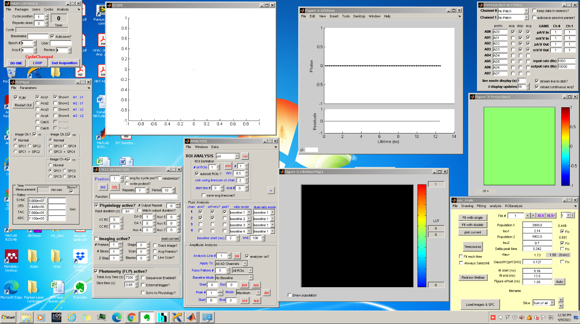

1. Click Do one in the main control window and set a new directory to your data folder. It is recommended to first save the data locally, before saving it on a server.
2. After a few seconds click abort. This button will retain the data in the workspace, but it will not save the data in the folder

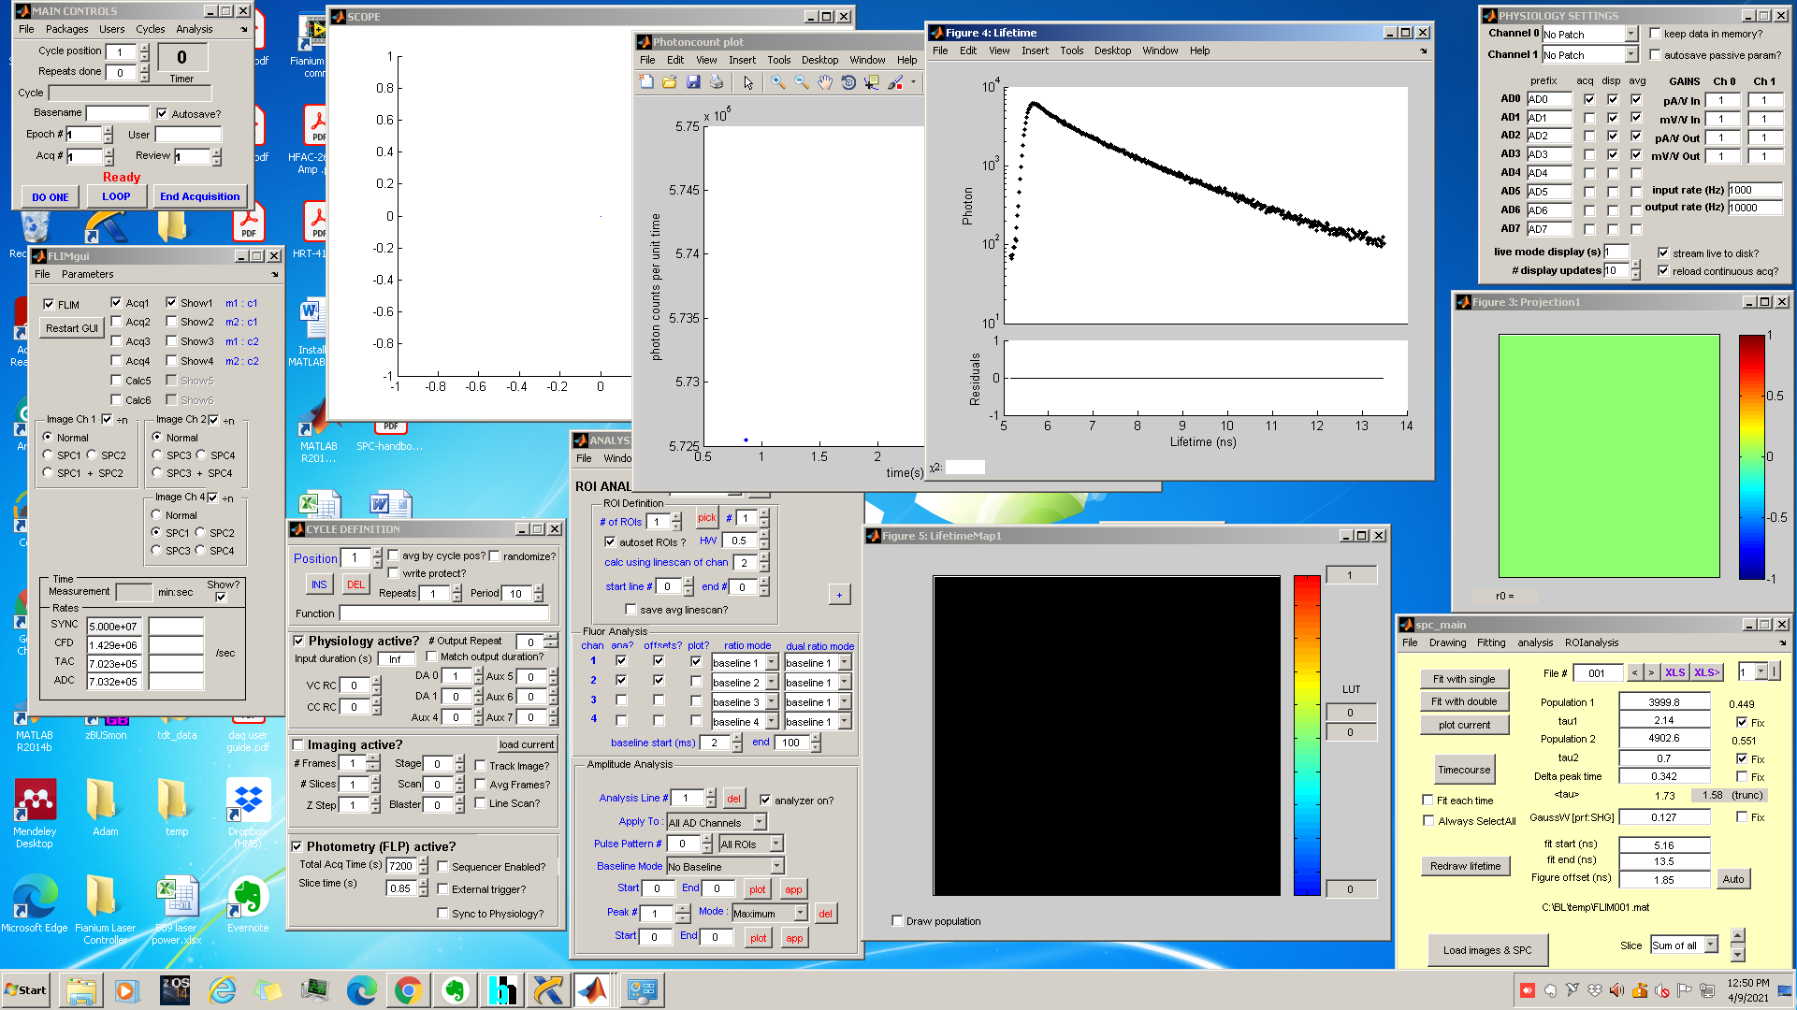

1. Find the time window for your fit by changing the fit start and fit finish values. Please note that there should be 2 clear peaks per 20ns, one auto fluorescent peak and a signal peak corresponding to the fluorophore of interest. Choose your time window to fit the decay curve as seen in the figure below. Then, when in the correct temporal range, click fit with single and then fit with double, to fit the data with a double exponential and calculate the lifetime.
2. After the histogram has been fit, click do one to start the measurement.

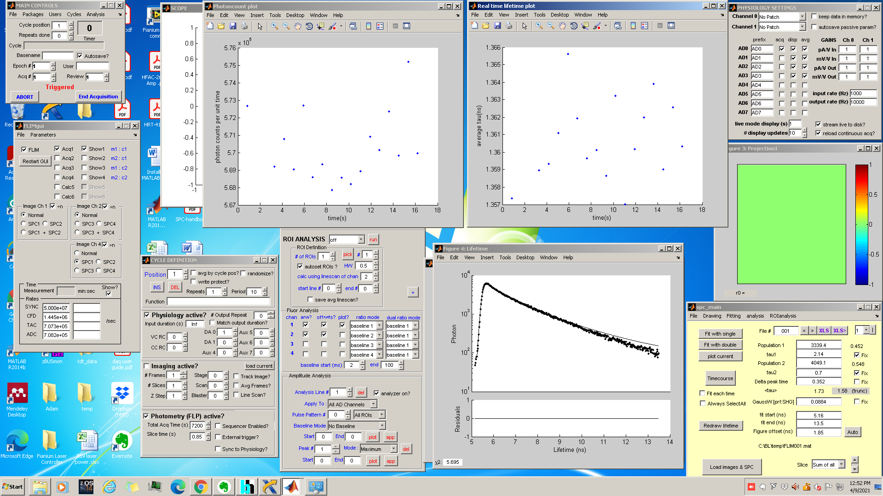

1. 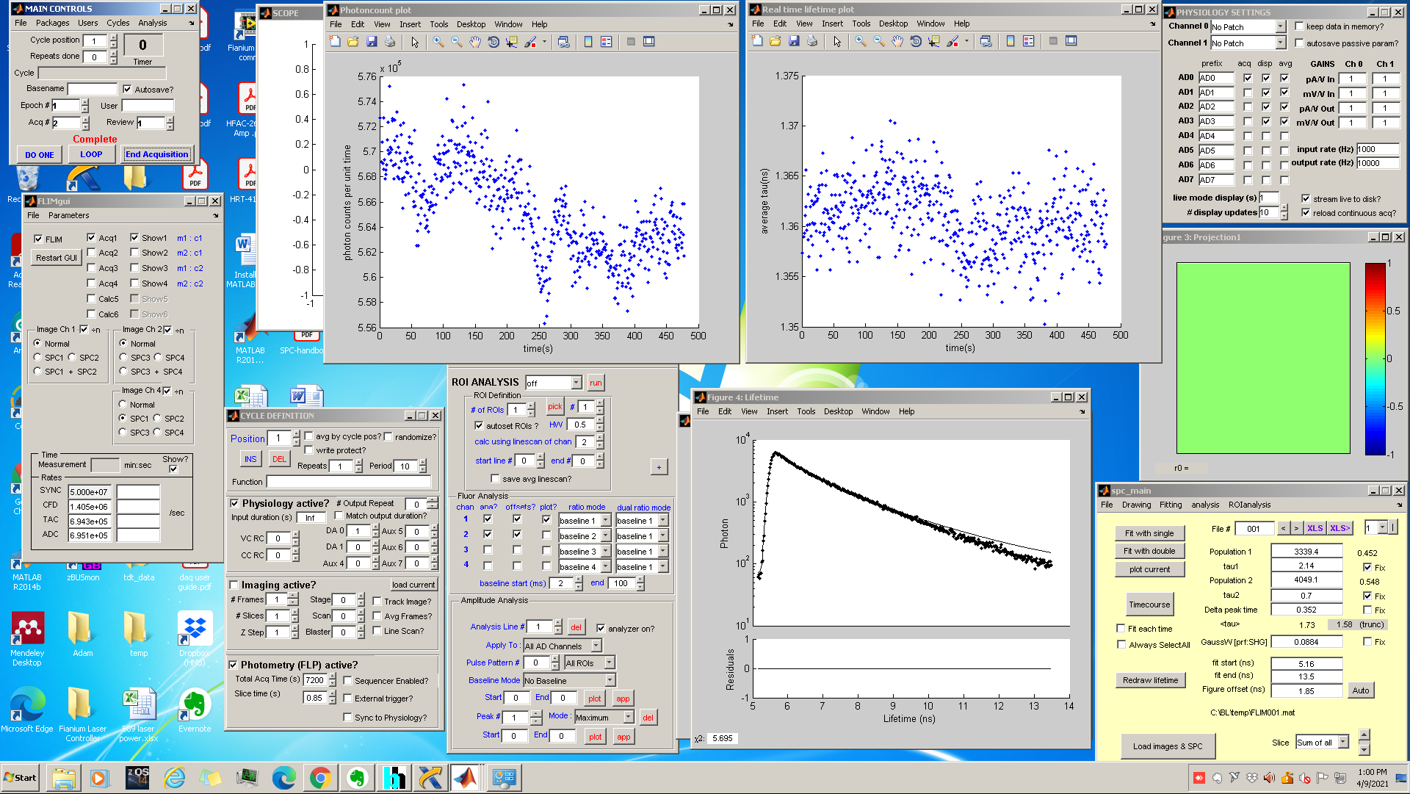During the experiment you can observe in real time the lifetime histogram of the last histogram collected in figure 4: Lifetime window, and the photoncounts and lifetime in the photoncount plot and real time lifetime plot, respectively. If you want to stop and save the recording before the total Acq time has been elapsed, click End Acquisition and all data will be saved. If you don’t want to save the data click abort.
2. After the acquisition you can start a new acquisition by again clicking do one and the newly collected data will saved in the previously set directory.
3. If changing the mouse or cannula:
   1. Make sure to close the shutter before taking the patch cord off as ambient light might overload the PMT.
   2. Set the intensity by following step 16
   3. Estimate the lifetime histogram by following step 17 till 20.
4. When your experiment is finished, close the shutter in front of the PMT, close matlab2012. Disable outputs in the DCC-100 application. Turn off the laser by turning the key. All data can be found in the folder selected at the beginning of the experiment.